**Ex.No: FOREIGN TRADING SYSTEM**

**Date:**

**AIM:**

To Design, Implement and Test the Exam Registration System described in the given problem statement.

**PROBLEM STATEMENT:**

Foreign Trading System involves details about the export and import of materials between two or many countries.

The main objective of this project is to ensure globalization and thereby ensuring that the buyers all over the world get the desired product that helps in the development of their globalization.

This software helps the trading system to be easy for the promoters and the buyers to maintain their exports and import details.

The database contains all the details of the export and import procedures.

The system consists of two databases to maintain this software.

* The import session
* The export session

**Export Session:**

The promoter has to maintain the details of the products that are been exported to other countries.

The bank’s certification details are maintained in database are

* Product name that is to be delivered
* The number of items to be exported
* The date and time of the product to be delivered
* The mode of transport through which the goods are sent
* The details of the transaction

**Import Session:**

The buyer has to maintain the details of the products brought from the foreign countries.

The bank’s certification should be issued to the import products.

The following details are maintained in database are

* Product name that is to be delivered
* The number of items to be imported
* The date and time of the product to be imported
* The mode of transport through which the goods are received
* The details of the transaction

**USECASE DIAGRAM:**

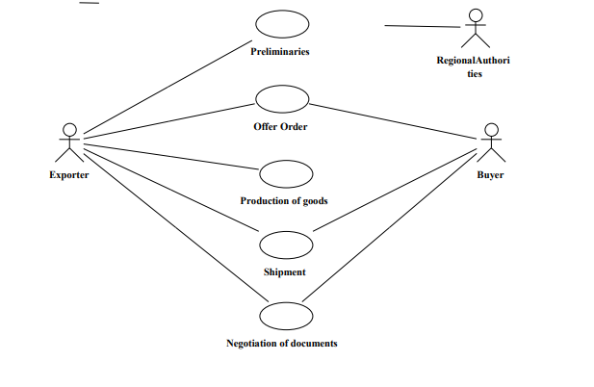

**CLASS DIAGRAM:**

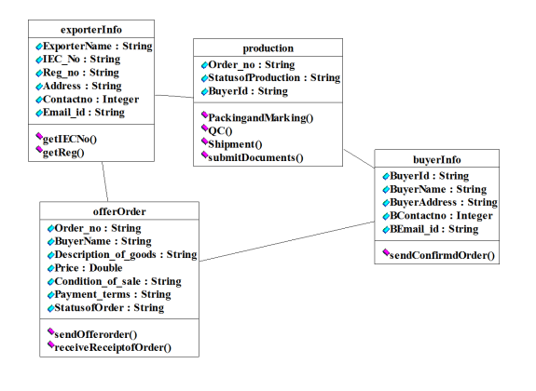

**SEQUENCE DIAGRAM:**



**ACTIVITY DIAGRAM:**

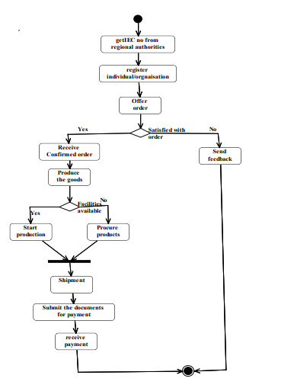

**STATE CHART DIAGRAM:**



**COMPONENT DIAGRAM:**



**DEPLOYMENT DIAGRAM**



**IMPLEMENTATION & TESTING**

**IMPLEMENTATION:**

**BUYER.java**

import java.util.*;

class BUYER

{

String name,country;

int id;

int phone;

void get_info()

{

System.out.println("\n******PROFILE******");

System.out.println("\nName : "+name+"\nID : "+id+"\nPhone : "+phone+"\nCountry : "+country);

}

void get_payment()

{

System.out.println("\n*******Payment********");

System.out.println("Transaction made successfully");

}

BUYER(String name, String country,intid,int phone)

{

this.name=name;

this.country=country;

this.id=id;

this.phone=phone;

}

}

**EXPORTER.java**

class EXPORTER

{

String name,country;

int id;

int phone;

void get_Offer()

{

System.out.println("\n*******OFFERS*******");

System.out.println("1.Electronics\n2.Food products\n3.Textile");

}

void get_Production()

{

int rand=(int)(Math.random()*100000000);

System.out.println("\n******Shipping******");

System.out.println("Shipment Id: "+rand+" has been made");

}

EXPORTER(String name, String country,intid,int phone)

{

this.name=name;

this.country=country;

this.id=id;

this.phone=phone;

}

}

**Exchange.java**

public class exchange {

public static void main(String[] args) {

String name,country;

int id;

int phone;

int b,c;

Scanner sc = new Scanner(System.in);

int e;

do

{

System.out.println("\n**********FORIGN EXCHANGE**********");

System.out.println("SELECT EXCHANGE");

System.out.println("1.EXPORTER \n2.BUYER\n3.EXIT");

int n = sc.nextInt();

switch(n)

{

case 1 :

System.out.println("Welcome exporter");

System.out.print("\nEnter Your name : ");

name=sc.nextLine();

name=sc.nextLine();

System.out.print("\nEnterID : ");

id=sc.nextInt();

System.out.print("\nEnter Phone no. : ");

phone=sc.nextInt();

System.out.print("\nEnterCountry : ");

country=sc.nextLine();

country=sc.nextLine();

EXPORTER f = new EXPORTER(name,country,id,phone);

do{

System.out.println("\nMENU");

System.out.println("\n1.Offer order \n2. Production\n3.Quit");

System.out.print("Enter your choice: ");

b = sc.nextInt();

switch(b)

{

case 1 :f.get_Offer();

break;

case 2 :f.get_Production();

break;

}

}while(b!=3);

break;

case 2 :

System.out.println("Welcome Buyer");

System.out.print("\nEnter Your name : ");

name=sc.nextLine();

name=sc.nextLine();

System.out.print("\nEnterID : ");

id=sc.nextInt();

System.out.print("\nEnter Phone no. : ");

phone=sc.nextInt();

System.out.print("\nEnterCountry : ");

country=sc.nextLine();

country=sc.nextLine();

BUYER d = new BUYER(name,country,id,phone);

do{

System.out.println("\nMENU");

System.out.println("1.View info \n2.Payment\n3.Quit");

System.out.print("Enter your choice: ");

c = sc.nextInt();

switch(c)

{

case 1 :d.get_info();

break;

case 2 :d.get_payment();

break;

}

}while(c!=3);

break;

default :

System.exit(0);

}

System.out.print("press 1 for home page : ");

e = sc.nextInt();

}while( e ==1);

}

}

**OUTPUT:**

**********FORIGN EXCHANGE**********

SELECT EXCHANGE

1.EXPORTER

2.BUYER

3.EXIT

1

Welcome exporter

Enter Your name : Praveen

Enter ID : 330

Enter Phone no. : 435262

Enter Country : India

MENU

1.Offer order

2. Production

3.Quit

Enter your choice: 1

*******OFFERS*******

1.Electronics

2.Food products

3.Textile

MENU

1.Offer order

2. Production

3.Quit

Enter your choice: 2

******Shipping******

Shipment Id: 16948196 has been made

MENU

1.Offer order

2. Production

3.Quit

Enter your choice: 3

press 1 for home page : 1

**********FORIGN EXCHANGE**********

SELECT EXCHANGE

1.EXPORTER

2.BUYER

3.EXIT

2

Welcome Buyer

Enter Your name : Ratheesh

Enter ID : 422

Enter Phone no. : 243652

Enter Country : Pakistan

MENU

1.View info

2.Payment

3.Quit

Enter your choice: 1

******PROFILE******

Name : Ratheesh

ID : 422

Phone : 243652

Country : Pakistan

MENU

1.View info

2.Payment

3.Quit

Enter your choice: 2

*******Payment********

Transaction made successfully

MENU

1.View info

2.Payment

3.Quit

Enter your choice: 3

press 1 for home page : 1

**********FORIGN EXCHANGE**********

SELECT EXCHANGE

1.EXPORTER

2.BUYER

3.EXIT

3

**TESTING:**

**TEST REPORT 1**

**Product :**FOREIGN EXCHANGE SYSTEM

**Use Case :**Exporter

|  |  |  |  |  |
| --- | --- | --- | --- | --- |
| **Test Case ID** | **Test Case / Action To Perform** | **Expected Result** | **Actual Result** | **Pass/Fail** |
| 1. c | Enter into  “Exporter“ | Displays the welcome message and prompts for the input from the user | Welcome Exporter | Pass |
|  | Provide the correct details | Displays the menu for services | 1.Offer order  2. Production  3.Quit  Enter your choice: 1 | Pass |
|  | Enter into offer order | Displays the offers provided | ******OFFERS*******  1.Electronics  2.Food products  3.Textile | Pass |

**TEST REPORT 2**

**Product :**Foreign Exchange System

**Use Case :**Buyer

|  |  |  |  |  |
| --- | --- | --- | --- | --- |
| **Test Case ID** | **Test Case / Action To Perform** | **Expected Result** | **Actual Result** | **Pass/Fail** |
|  | Enter into “Buyer Section” | Displays the welcome message and prompts for input from the buyer | Welcome Buyer | Pass |
|  | Provide the correct details | Displays the menu for buyer | 1.View info  2.Payment  3.Quit  Enter your choice: 1 | Pass |
|  | Enter into payment section | Initiates the payment | Transaction made successfully | Pass |